Databases Artifact

Muhammad Khizer

## Database Creation

The database, labeled as SNHU, was set up as part of this enhancement strategy. You can view the database in the provided screenshot, located under the database tab within MongoDB Atlas.

## Add New User – Admin Rights

A new user was added after the initial setup, equipped with password authentication and Atlas admin privileges.

## Add Network Access – Home and Work

Multiple IP addresses were configured under the network access tab to facilitate access from both my home and work computers while working on the enhancement plan.

## MongoDB Shell Install Instructions

The provided instructions detail the installation of the MongoDB Shell for various operating systems. I selected Windows and completed the installation process accordingly.

## MongoDB Shell Connection Instructions

Following the installation of the MongoDB Shell, I checked the installed version using a command prompt on Windows and confirmed that it was version 1.8.0.

## MongoDB Shell Successful Connection

I successfully logged into the database using the MongoDB shell method, as demonstrated in the screenshot provided.

## Loading Sample Set Through Atlas GUI

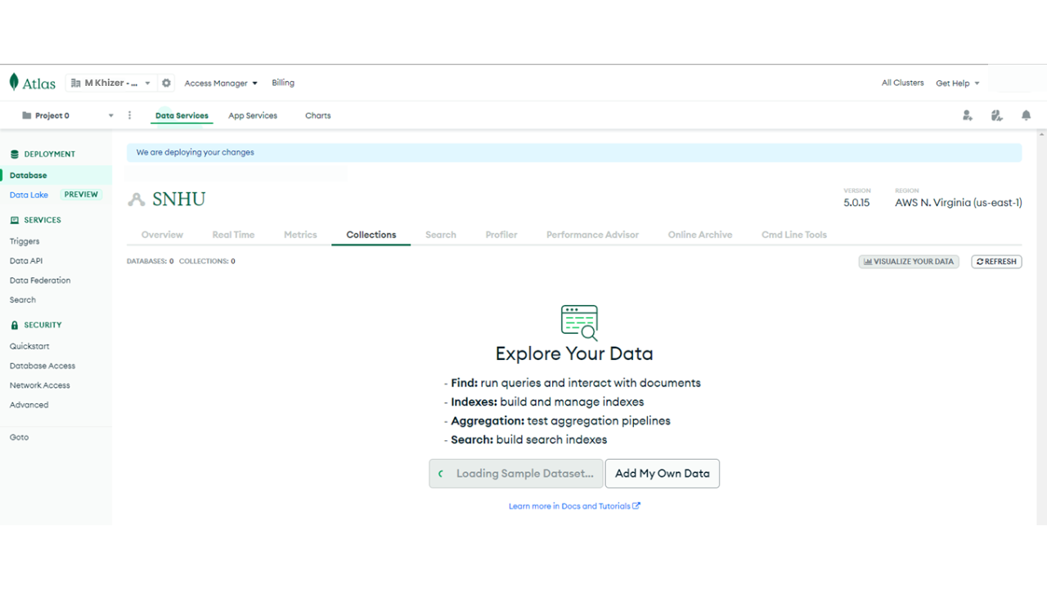I discovered that the database could be manipulated using the included GUI, which I found intriguing given that my previous courses only taught database interaction through shell commands. The screenshot shows the beginning of the process where I am loading a sample dataset, which I plan to use later to demonstrate additional functionalities.

## Viewing Collections Within Database

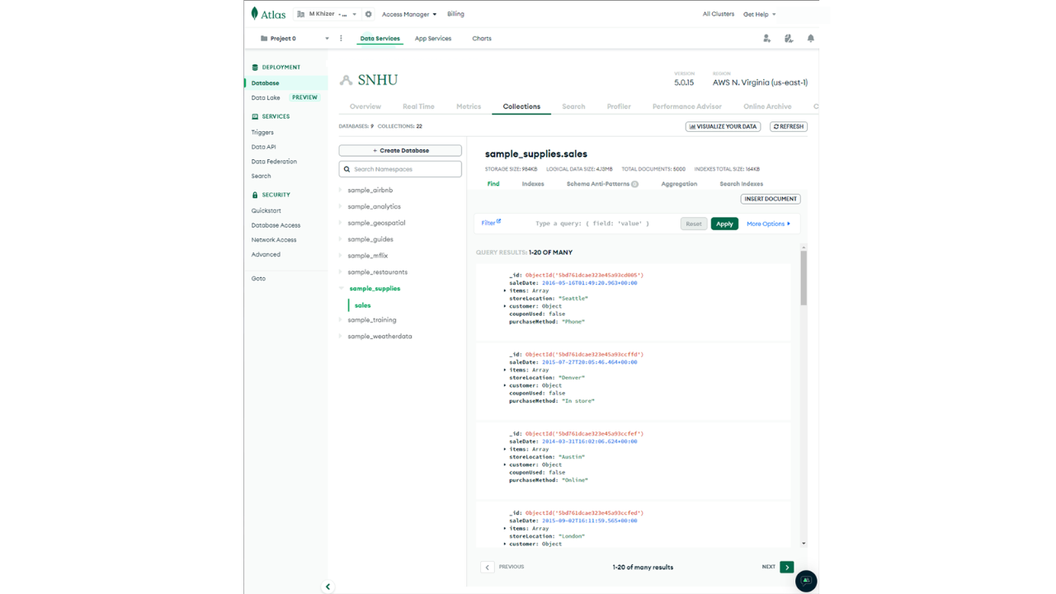

The sample datasets are visible under the collections tab, indicating they were successfully loaded into the database.

## Visualizing Queried Data Within a Collection

Using the GUI, data can be queried and manipulated effortlessly to generate insightful information through visualizations. The example provided illustrates the number of items sold by each store location. The results indicate that the stores with the highest sales, in descending order, are Denver, Seattle, London, Austin, New York, and then San Diego.

## Data Visuals Stored for Later Use

The visualizations created can be saved in a dashboard for future use and reference. This feature is beneficial for quickly creating and storing various types of valuable information.